**Project idea**

**Overview**

My project idea is to add an additional feature or functionality to digital cameras so that they can capture images of transparent or partially transparent objects and automatically retain their transparency.

**Motivation**

Photographing items that are deteriorating is a common preservation strategy and many archives throughout the world do this to preserve transparencies and negatives. However, in the case of transparencies and negatives they lose some of their functionality and original qualities as transparencies are no longer transparent and negatives are no longer negatives.

**Digital copying**

I work for National Archives of Australia and we have a preservation digitisation program to copy photographic records that are deteriorating or are at risk. Each year approximately 30,000 images are digitised and made accessible through [RecordSearch](https://recordsearch.naa.gov.au/SearchNRetrieve/Interface/SearchScreens/BasicSearch.aspx) and this includes negatives and transparencies. [National Archives of Australia (NAA) 2019, para 8] Photographic negatives and transparencies, (positive images) can be black and white or colour.

Like other photographic formats they have a gelatin image layer generally made of cellulose nitrate and acetate which can deteriorate irreversibly over time. When cellulose nitrate deteriorates it releases distinct acrid vapors (nitrogen oxides) that are corrosive to various materials and a human health risk. As acetate film deteriorates it releases acetic acid that gives it a vinegar smell (known as vinegar syndrome). As deterioration progresses the film base shrinks and becomes brittle, eventually the emulsion layer buckles and separates from the base. It can also develop bubbles under the emulsion layer and white crystalline deposits on the surface. Ideally, both nitrate and acetate negatives should be kept isolated from other collection material because of the damaging vapors they produce. (NAA 2019 para 3, 9 & 10)

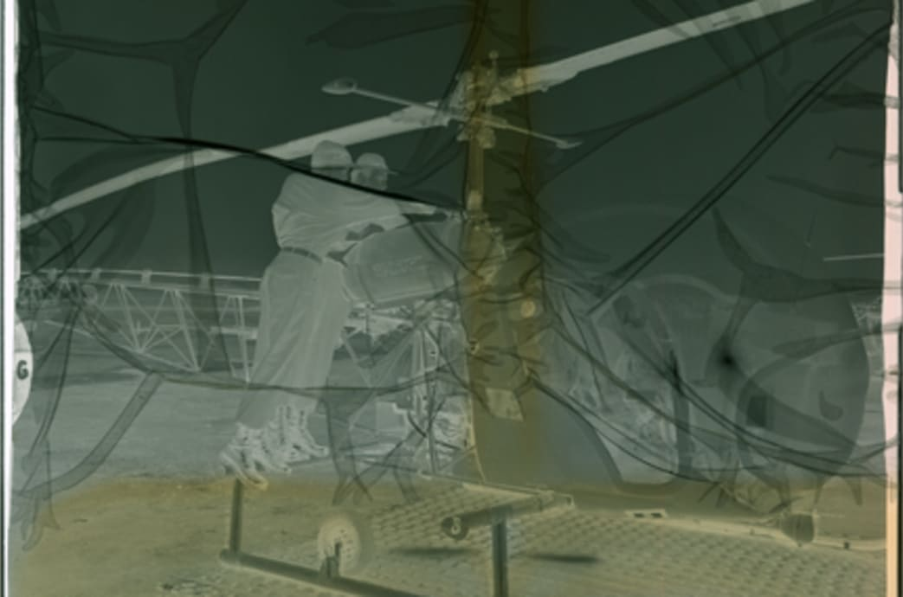

Rogers, S, *An Aviation History Emergency,* Indiegogo, viewed 16 June 2019, <https://www.indiegogo.com/projects/an-aviation-history-emergency#/>

Copying photographic images is a standard preservation strategy. However, when negatives or transparencies are photographed, they lose their transparent quality and therefore some of their functionality. For example, in the case of transparent overlays for maps that were intended to be multilayered, you lose the ability to layer them, and depending on how they have been photographed ie one transparency over the map at a time, this may be difficult to reverse.

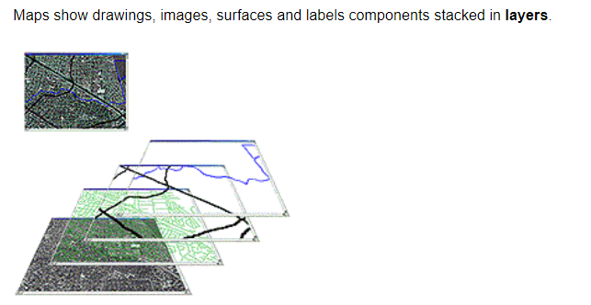

Manifold.net, *Layers*, viewed 13 June 2019 <http://www.georeference.org/doc/layers.htm>

If they are photographed using lighting or a solid background this can be removed later with a photo editing tool such as Adobe Photoshop, Photo-Paint, Paint Shop Pro, GIMP, Paint.NET, StylePix, but this involves extra work and therefore resourcing and costs.

Adding this function to camera software would mean that you would not have to download them elsewhere to edit them, they could immediately be ready to use or publish.

**Tool and technologies**

As the software to edit or re-colour backgrounds to transparent already exists, it should be possible to include this functionality into cameras now. In the case of removing an image’s background, there are already a few [open-source algorithms](https://twitter.com/zaidalyafeai/status/1074372819398651906) that could be integrated into cameras. (TheVerge 2019). Others available include:

Background burner <https://burner.bonanza.com/>

Lunapic <https://www110.lunapic.com/editor/?action=transparent>

The functionality should be able to be embedded into current camera software and hardware.

**Skills Required**

You would need a software engineer to add these open-source algorithms and integrate them into current camera technology. This is a very feasible project and is already most likely already available in other technology, such as those used by military and although they are separate both technologies could already be used on mobile devices such as phones.

**Outcome**

Apart from addressing the initial preservation issue, making instant transparent images would have many social and commercial applications in phone apps, graphic design, advertising, web publishing and many more. The popularity of websites like PNGmart, that make available 43,429+ free high-quality, is indicative of the broad market for transparent images. Shutterstock also lists that they have 4,409,378 transparent stock photos, vectors, and illustrations available royalty-free.

Commercially transparent images could be used for creating logos or web graphics that will stand out on any colour background (Befunky 2019). Businesses, crafters or students could all use the images to create faint, delicate impressions for invitations or cards, or paired with text or graphs for a punchy visualization for a marketing campaign or assignment. You could combine semi-transparent images with other elements to create captivating overlays and textured effects. Shapes could be used as text-holders or to add a watermark to a design or document, the possibilities are only limited by your imagination (Canva 2019).

**References**

Background burner, *Remove backgrounds from images*, viewed 15 June 2019 <https://burner.bonanza.com/>

Be funky, 2019, *Create Transparent Backgrounds with Ease*, viewed 14 July 2019, <https://www.befunky.com/features/transparent-background/>

Canva, 2019, Create Soft, Dreamy Designs with Transparent Images, viewed 14 July 2017, <https://www.canva.com/features/transparent-images/>

Lunapic, *Transparent Background Tool*, viewed 15 June 2019, i<https://www110.lunapic.com/editor/?action=transparent>

Manifold.net, *Layers*, viewed 13 June 2019 <http://www.georeference.org/doc/layers.htm>

National Archives of Australia (NAA) 2019, *Preserving photographs and microforms*, viewed 12 June 2019, para 8 <http://www.naa.gov.au/collection/preserving/photographs-and-microforms/index.aspx>

National Archives of Australia (NAA) 2019, *Preserving photographs*, viewed 12 June 2019, paras 3, 9 & 10, <http://www.naa.gov.au/information-management/managing-information-and-records/preserving/photographs.aspx>

PNGMART, 2019, *Download Free PNG Images Transparent Backgrounds*, viewed 14 July 2019, <http://www.pngmart.com/>

Rogers, S, *An Aviation History Emergency,* Indiegogo, viewed 16 June 2019, <https://www.indiegogo.com/projects/an-aviation-history-emergency#/>

Vincent, J 2018, ‘*This free online tool uses AI to quickly remove the background from images*’ The Verge, 2019 para 2, viewed 15 June 2019, <https://www.theverge.com/2018/12/19/18148020/remove-bg-ai-background-foreground-without-photoshop>